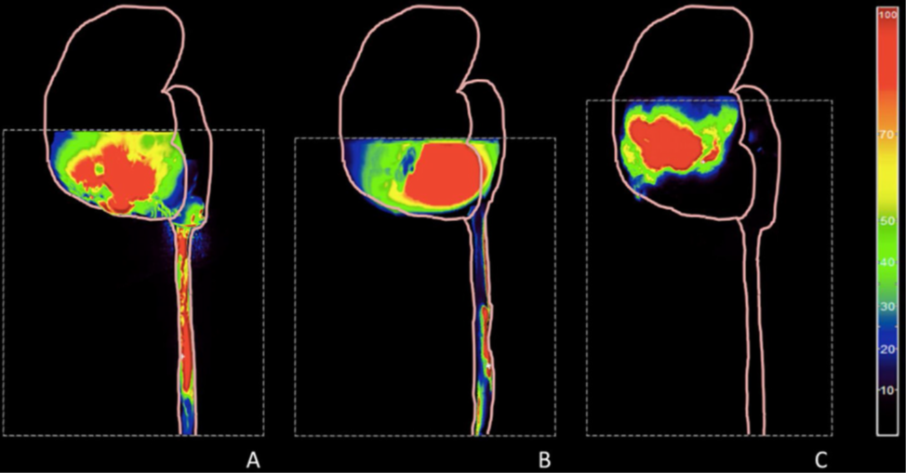

Figure 1: Projection on a transplant diagram of an intraoperative image of indocyanin green fluorescence of a ureter in semi-quantitative analysis. A) Complete and intense fluorescence of the ureter except the last centimeters in favor of good vascularization. B) Partial and weak fluorescence of the ureter in favor of weak and partial vascularization. C) Zero fluorescence of the ureterand the lower pole of the transplant in favor of no vascularization of the ureter and the lower pole of the transplant. Illustration: H. Boullenois et al. 2020

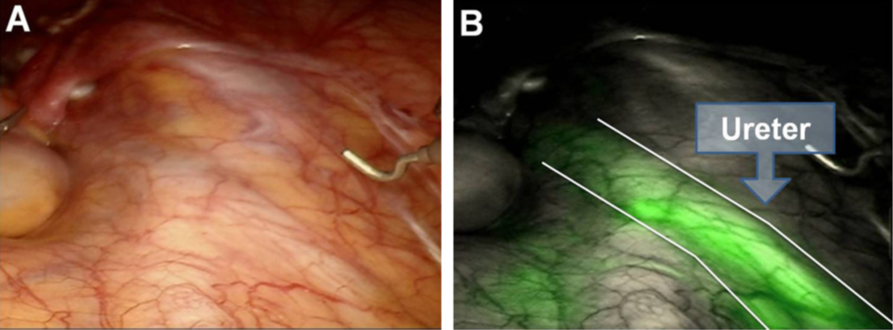

Figure 2: Ureteral identification (A) in the absence of near-infrared fluorescence (NIRF) and (B) under NIRF. Reproduced with permission from Ziho Lee et al. 2015